Laboratory 16: Matlab and Data Analysis
(Edit this document as needed)

Partner 1: __________Saaif Ahmed________________

Partner 2: _________John Gonzalez_______________

Partner 3: _______________________________ (if needed)

Part A
Brief description of the Matlab diode plotting experiment:
To delve deeper into Matlab’s capabilities of plotting and to determine the difference between a standard diode and an ideal diode and the same for an LED.

Plot of the diode current (I_{D}) vs. the diode voltage (V_{D}) for a standard diode. (Matlab)

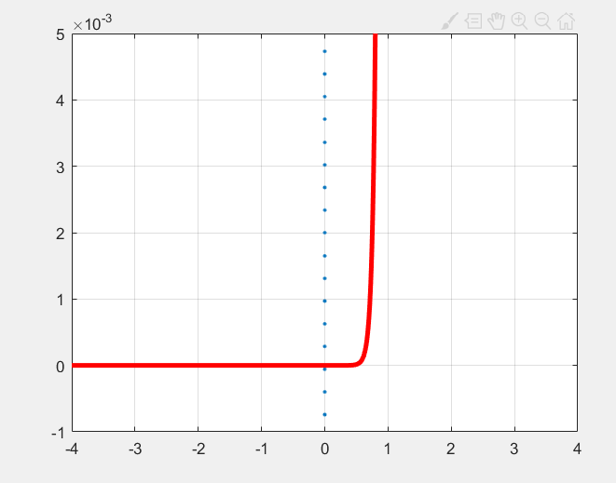

Plot of the experimental I_{D}-V_{D} and the calculated ID using 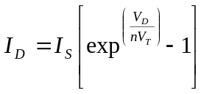 for a standard diode. (Matlab)

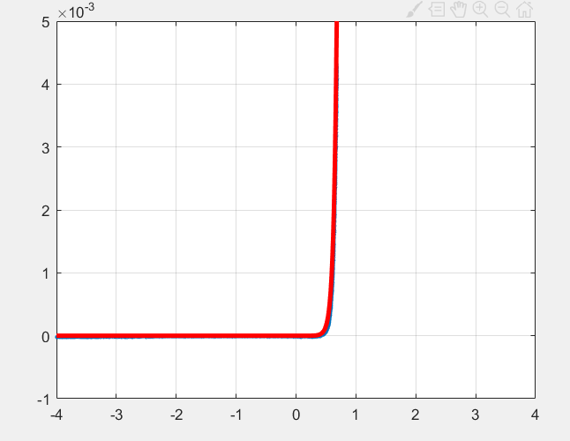

Value of I_{S} and n in your fitted curve.

I_{S} | 1e-8[A]
n | 2

Plot of the diode current (I_{D}) vs. the diode voltage (V_{D}) for a LED. (Matlab)

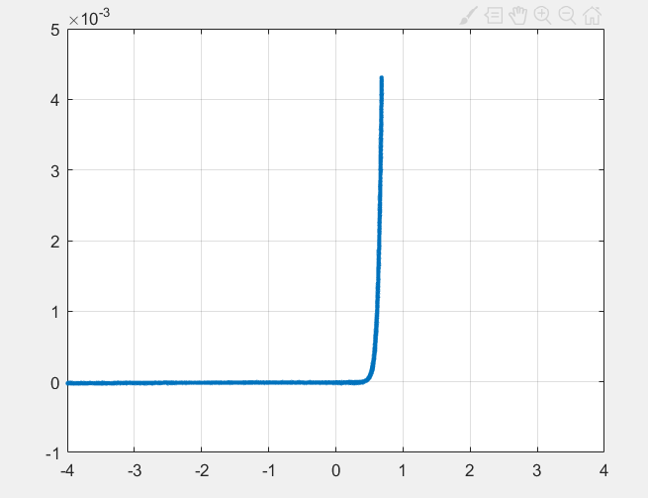
Plot of the experimental I_{D}-V_{D} and the calculated ID using for a LED. Matlab)

Value of I_{S} and n in your fitted curve.

I_{S} | 1e-7[A]
n | 2

Experimental and analytical plots verification by TA/Instructor. ________HC_______

Part B
Brief description of the Load Line experiment:

To reference the load of a circuit in the form of I=AV+B and to be able to analyze graphically the operational points of circuit components(diodes).

Mathematical expression for the current through the resistor in terms of the source voltage (V_{S}) and the resistance, R.

I=(-1/R)V+(V_{s}/R)

Plot of load line on the following experimental curve.

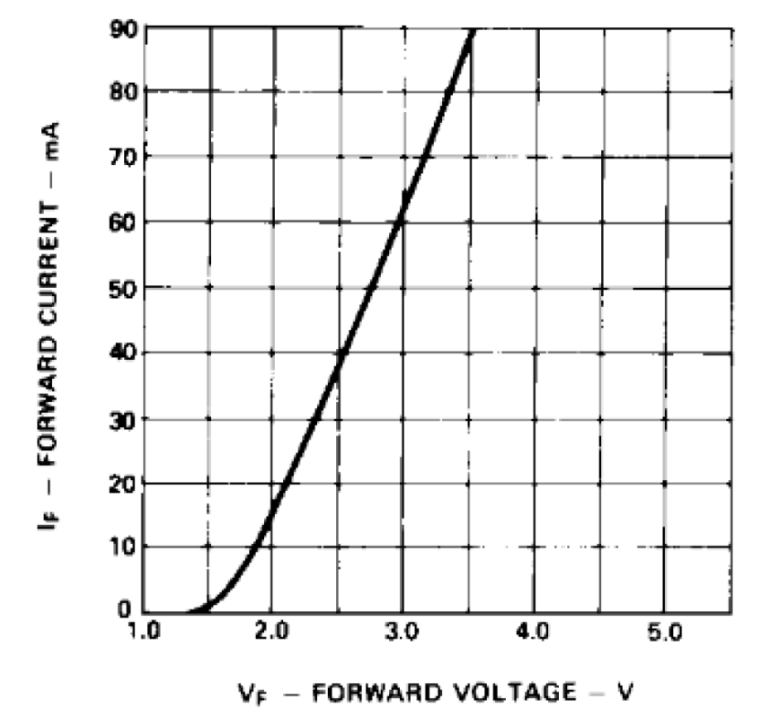
Y-intercept 80mA
X-intercept 5V

Load line plot verification by TA/Instructor. ________________HC______________

Approximate diode (resistor) current and diode voltage using the load line analysis on the above plot.

I_{D} | 0.048[A]
V_{D} | 2.7[V]

Plot with load line for standard diode using experimental data from part A.

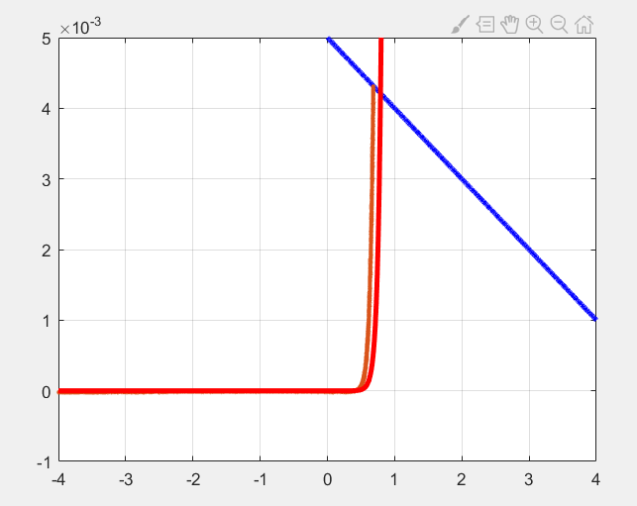

Approximate diode (resistor) current and diode voltage using the load line analysis on the above plot.

I_{D} | 0.005[A]
V_{D} | 0.67[V]

Plot with load line for LED using experimental data from part A.

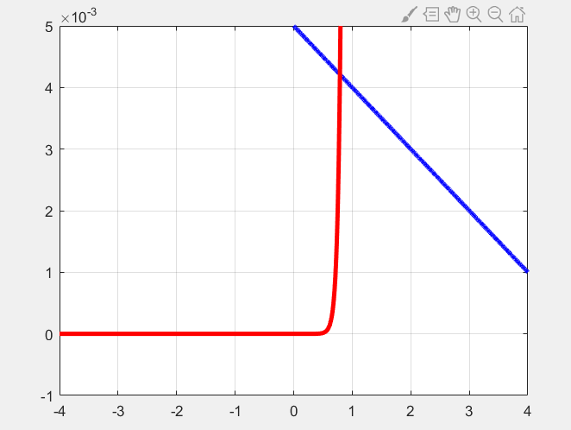

Approximate diode (resistor) current and diode voltage using the load line analysis on the above plot.

I_{D} | 0.004[A]
V_{D} | 0.8[V]

